LIMIT REFERENCE POINTS AND WILD SALMON POLICY RAPID STATUS SUMMARY:

2023 FRASER –SUMMER 0.3 CHINOOK STOCK MANAGEMENT UNIT

Context
A key recommendation from a CSAS peer review process on Pacific Salmon Limit Reference Points (LRPs) is ‘CU [conservation-unit] status-based LRPs’ be used to meet the Fish Stocks provisions of the Fisheries Act (DFO 2022; Holt et al. 2023a, 2023b), which was supported nationally (DFO 2023). LRP's are assessed for Stock Management Units (SMUs), which can include one or more conservation units (CUs) (i.e., CUs are nested within SMUs). Using this approach, serious harm to a SMU is identified when any component CU zone drops into the Wild Salmon Policy (WSP) Red zone. Under this definition, the CU status-LRP is ‘100% of CUs with statuses above Red status’. The implications are that if a single CU is the Red status zone, the SMU is assessed as being below its LRP, which in turn triggers a DFO rebuilding plan for the SMU.

Forewords
Expert reviewers expressed concerns that the Wild Salmon Policy Rapid Status Algorithm does not account for changes in spawner distribution within CUs. Because the scanner only uses total CU spawner abundances and/or trends in abundances, it assumes that CUs with even versus uneven spawner distributions relative to the productivity of each component population are equally healthy. Declining eveness in spawner distribution within a CU may signal a productivity decline, but relatively large and productive populations can temporarily mask a decline when solely using total CU abundance to estimate status.

Data
The Summer 0.3 Chinook SMU contains three CUs (Maria Slough; South Thompson ; Shuswap River). These three CUs comprise of a total of 8 systems, 7 of which are included in this assessment (Table 1). The last integrated status assessment for this SMU occurred for return year 2012 (DFO 2016). Some of the data were also recently used in the Fraser Chinook Recovery Potential Assessments (Dionne et al. 2023).
The primary forms of spawner enumeration surveys vary across the CUs within this SMU. There is also variation in enumeration methods throughout the time series for some CUs within this SMU. Maria Slough and South Thompson CU data were collected by visual surveys with a peak count expansion factor applied. Visual survey coverage ranged from moderate effort (1-4 surveys) to high effort (> 5 surveys) from 1996-2023. Shuswap River data were collected using mark recapture methods, with separate mark recapture programs running in the Lower Shuswap River (2000-2023) and Middle Shuswap River (2006-2023). Historical data (pre-mark-recapture) for both Lower (1975-1999) and Middle Shuswap River (1975-2005) have been calibrated so that they are equivalent to the mark-recapture data.
Key steps in the data processing of this data set includes assessing data quality, which are described in detail in Pestal et al. (2023). Data quality is assessed based on the number and completeness of surveys, coverage of the spawning period, visibility and reliability records, and methodology.
Spawner data quality were moderate on average, with high quality data available in the last couple of decades for Middle and Lower Shuswap Rivers in the Shuswap River CU. Shuswap River CU data are appropriate to be treated as absolute abundance and can be assessed against both absolute and relative abundance metrics. Maria and South Thompson CU data are relative indices, and consequently were not assessed against relative nor absolute abundance metrics.
Relative Abundance Benchmarks:
CU-specific relative abundance benchmarks for this SMU were developed using two different methods. For Maria Slough and South Thompson SU 0.3, benchmarks were produced using the habitat-based methods from Parken et al. (2006). For Shuswap River SU 0.3 CU, benchmarks were calculated from Ricker stock recruit models fit to the Lower Shuswap stock-recruit timeseries and the habitat-based benchmark was used for the Middle Shuswap River. Wap Creek is data deficient, thus omitted from the estimate of the benchmarks and the sum of spawners returning to the Shuswap River CU. The 50th percentile benchmarks are presented for each CU (Table 2).
Table 1. Conservation Units (CUs) included in this Stock Management Unit (SMU) and lists of the streams/populations within each CU used in the Rapid Status Assessment. Streams have their NuSEDS population identifications in brackets.
CU No# | CU Name | Streams (Population ID) | Timeseries
CK-07 | Maria Slough SU 0.3 | Maria Slough (47096) | 1996-2023
CK-13 | South Thompson SU 0.3 | Adams River (46246)  Little River (46236)  South Thompson River (46226)  Thompson River (46165) | 1975-2023
CK-15 | Shuswap River SU 0.3 | Shuswap River-Lower (46437)  Shuswap River-Middle (46447)  Wap Creek (46527) | 1975-2023

Table 2. Relative abundance-based benchmarks by Conservation Unit (CU). The upper benchmarks are 85% S_{MSY} and the lower benchmarks are S_{gen}. Upper Benchmarks are multiplied by 1.1 in the algorithm.
CU Name | Benchmark | p50
Maria Slough SU 0.3 | 85% S_{MSY} | 200
Maria Slough SU 0.3 | S_{gen} | 15
South Thompson SU 0.3 | 85% S_{MSY} | 43,925
South Thompson SU 0.3 | S_{gen} | 19,313
Shuswap River SU 0.3 | 85% S_{MSY} | 24,394
Shuswap River SU 0.3 | S_{gen} | 12,410

WSP Rapid Status Summary
Stock Management Unit (SMU) Limit Reference Point (LRP) status and narrative based on expert consensus
There are three CUs in the Summer 0.3 Chinook SMU and they are designated as 1 Red, and 2 Green, placing this SMU below the LRP in terms of WSP rapid status (Figures 1-6 & Table 3).

CK-07 Maria Slough SU 0.3
During the expert review meeting, it was discussed whether the Absolute Abundance Metric should be considered for use, which would change the status from Red with Medium Confidence to Red with High Confidence given that reviewers have high confidence that recent returns are less than 1500 spawners. However, there were two high return years in the time series where index estimates did not quite reach 1500 spawners and there is uncertainty in what the estimated carrying capacity of Maria Slough is given the addition of restoration channels and habitat improvements. This means that considering the data as Absolute Abundance may result in an inaccurate characterization of historical statuses. Thus, because only the confidence in the status would change but not the status itself, it was decided to continue to assess the population treating the data as relative index abundance.

CK-13 South Thompson SU 0.3
During the expert review meeting, it was noted that the Little Shuswap River pilot project will be an emerging indicator stock for this SMU, and the Middle Shuswap River will be retired as an indicator stock once the Little River Program proves feasible. The Middle Shuswap mark recapture program is going to be retired for 2 reasons: 1) it is currently 1 of 2 indicators in the same CU within the SMU (and thus does not improve the representation of the SMU as a whole), and 2) The Wilsey Dam is going to be removed sometime in the next 5-10 years, and once it is removed there will be too much available spawning area for stock assessment to effectively cover and dead pitch for a mark-recapture program. The Shuswap Falls Hatchery will continue to produce hatchery fish for the Middle Shuswap River at reduced rates to seed the river above the dam site, aiding in the recolonization of the upstream area.

CK-15 Shuswap River SU 0.3
During the expert review meeting, there was agreement to highlight that this system experiences large fluctuations in escapement. The 2024 return may change this status back to Amber in the next analysis.
Future work: Future work for this SMU will include proving the feasibility of the Little Shuswap River mark-recapture and determining the 85% S_{MSY} of the system so that it can be incorporated into the status assessments for the SMU.
Table 3. Wild Salmon Policy (WSP) Rapid Statuses for 2023. For background, refer to Appendix 1.
CU # | CU Name | WSP Rapid Status (YYYY) | WSP Rapid Status Node and Pathway
CK-07 | Maria Slough SU 0.3 | RED,  MEDIUM | The recent year’s status (2023) is designated Red with a medium confidence based on the algorithm. The data could be assessed as Relative Index. The recent generational average is 38 spawners, and is below the long term average (Node 17; Figure 2, Table 4). This Red status has been consistent throughout the status time series from 2017 to 2023 (Figure 1).
CK-13 | South Thompson SU 0.3 | GREEN,  LOW | The recent year’s status (2023) is designated Green with a low confidence based on the algorithm. The data could be assessed as Relative Index. The recent generational average is 200,125 spawners, and is above 233% of the long term average (Node 64; Figure 4, Table 5). This Green status has been consistent throughout the status time series from 1998 to 2023 (Figure 3). The 2023 WSP rapid status of Green matches the WSP integrated status from 2012 (DFO 2020).
CK-15 | Shuswap River SU 0.3 | GREEN,  HIGH | The recent year’s status (2023) is designated Green with a high confidence based on the algorithm. The data could be assessed as Absolute Abundance. The recent generational average is 34,879 spawners, and above the relative abundance upper benchmark (Node 36; Figure 6, Table 6). This Green status has changed from the Amber status time series from 2012 to 2022 (Figure 5).

CK-07 Mariah Slough SU 0.3

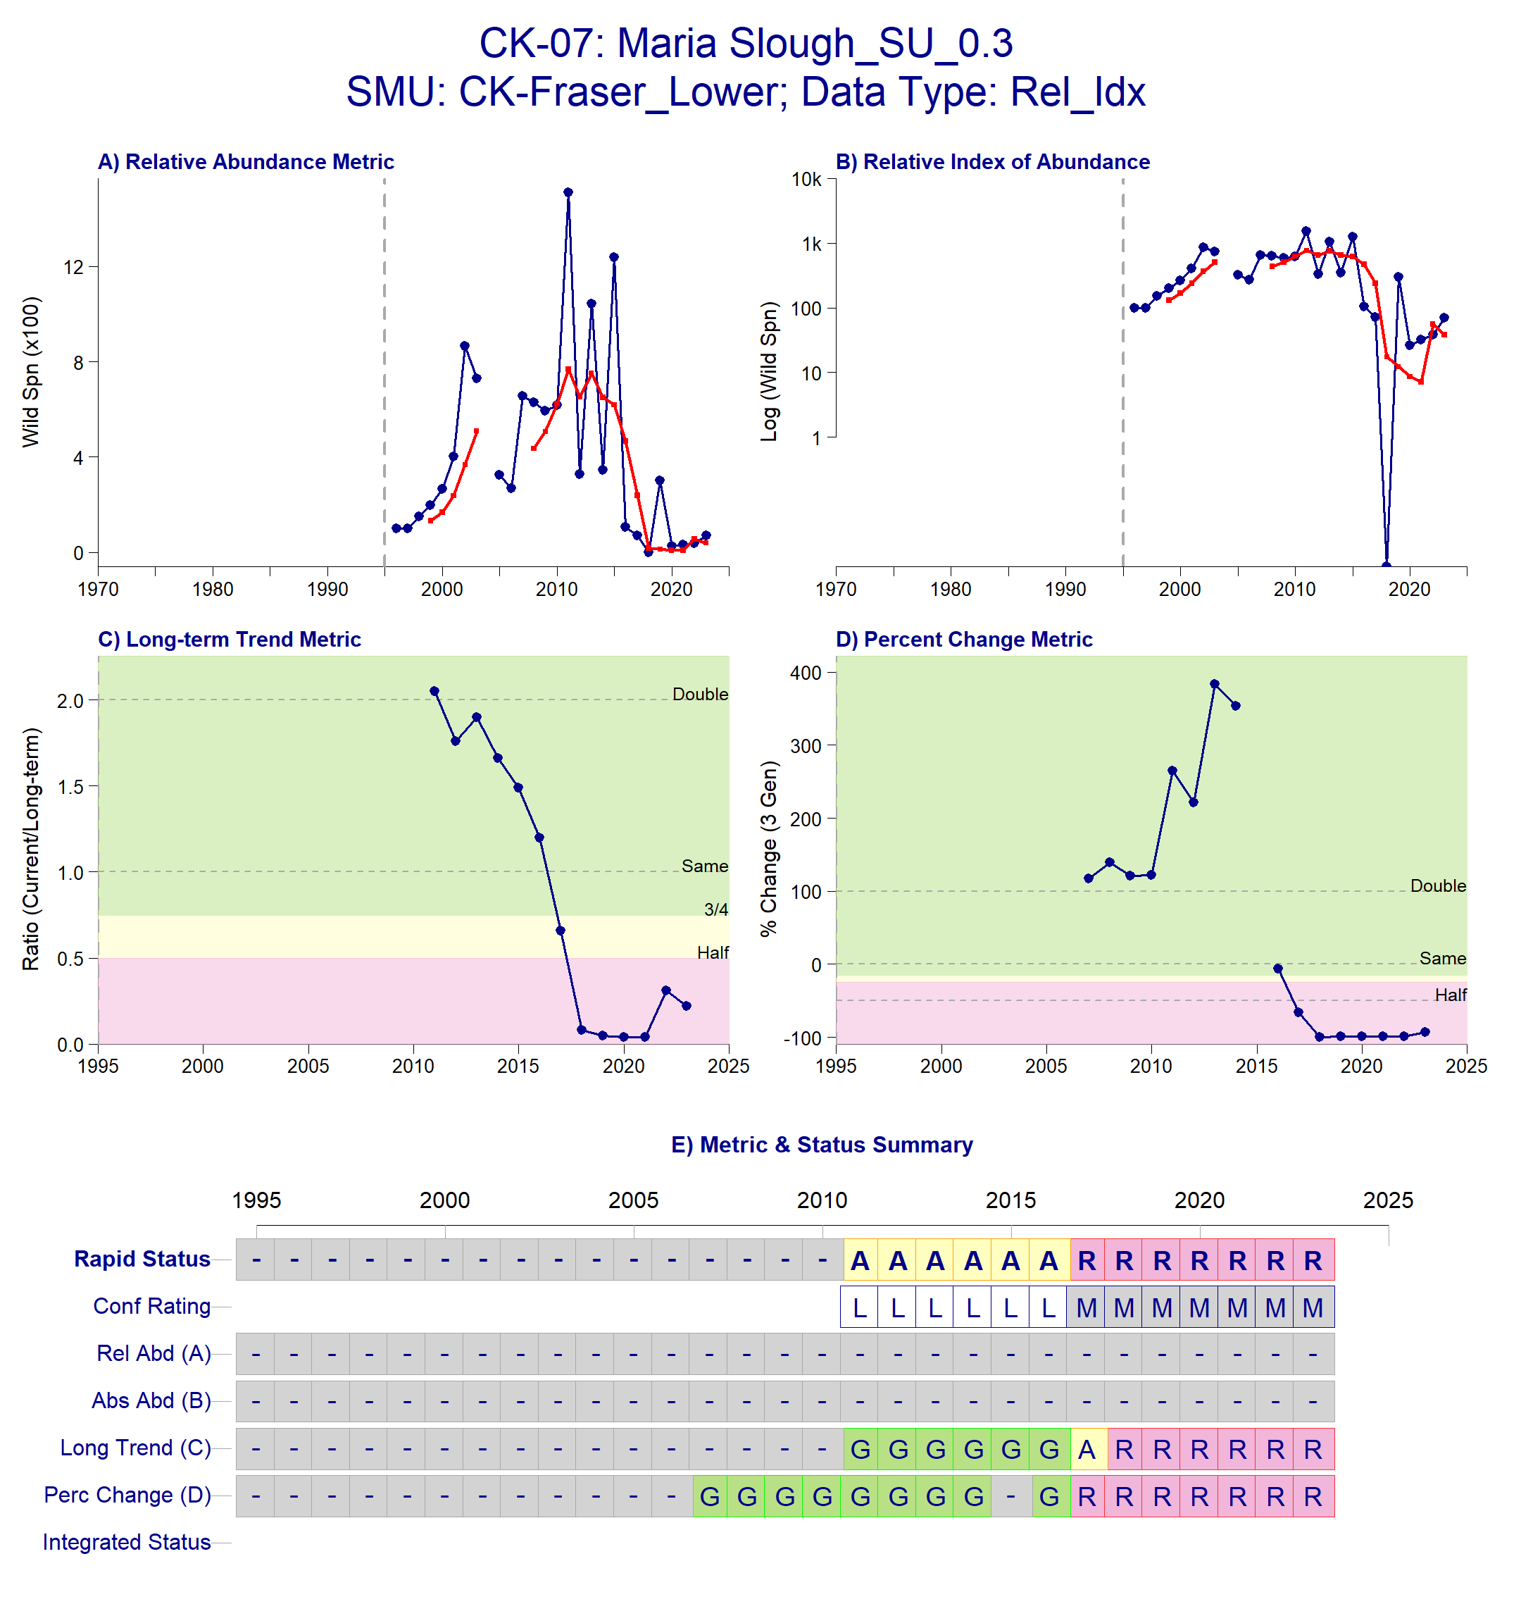
Figure 1: Metrics and Status for Spring SU 0.3 (CK-07). Panels on top show the four standard WSP metrics, calculated based on the available time series of spawner abundances. Bottom panel summarizes the status for each individual metric and shows the resulting WSP rapid status for the CU with a confidence rating. If integrated WSP status assessments have been completed for this CU, they are shown on the last row (IntStatus). Note that metric benchmarks may differ from algorithm thresholds, since thresholds approximate the status determination process from past WSP integrated status assessments (see Figure 2 and Table 4).
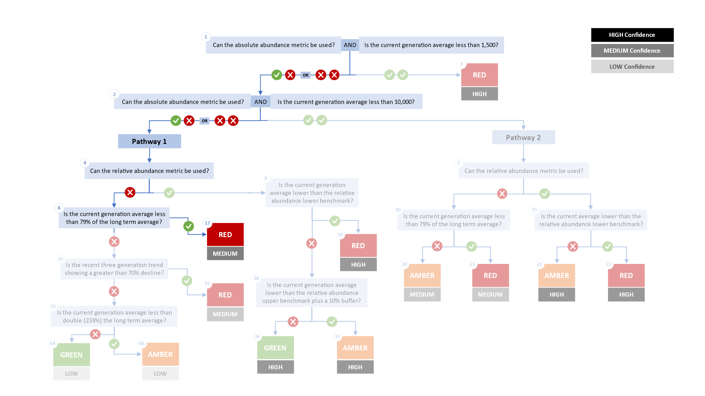

Figure 2. Algorithm pathway taken to assess status for the Maria Slough SU 0.3 in 2023. The recent generational average falls below the 79% of the long term average threshold (node 8). Status for this CU is therefore designated as Red with Medium confidence at Node 17.
Table 4: Decision tree path given data and metric values for the Maria Slough SU 0.3 in 2023; this aligns with Figure 2 above. For each node, the algorithm decision is made by comparing the CUs current metric value to the metric threshold and answering Yes or No, running through sequential nodes and decisions until the final WSP rapid status for that CU and year is reached.
Node | Metric | Metric Threshold | CUs Current Value | Decision
1 | Absolute Abundance | <1,500 | 38 | NO, NO
2 | Absolute Abundance | <10,000 | 38 | NO, NO
4 | Relative Abundance | Available? |  | NO
8 | Long term trend | <79% of long term average |  | YES
17 | FINAL STATUS NODE |  |  | RED, MEDIUM

CK-13 South Thompson SU 0.3
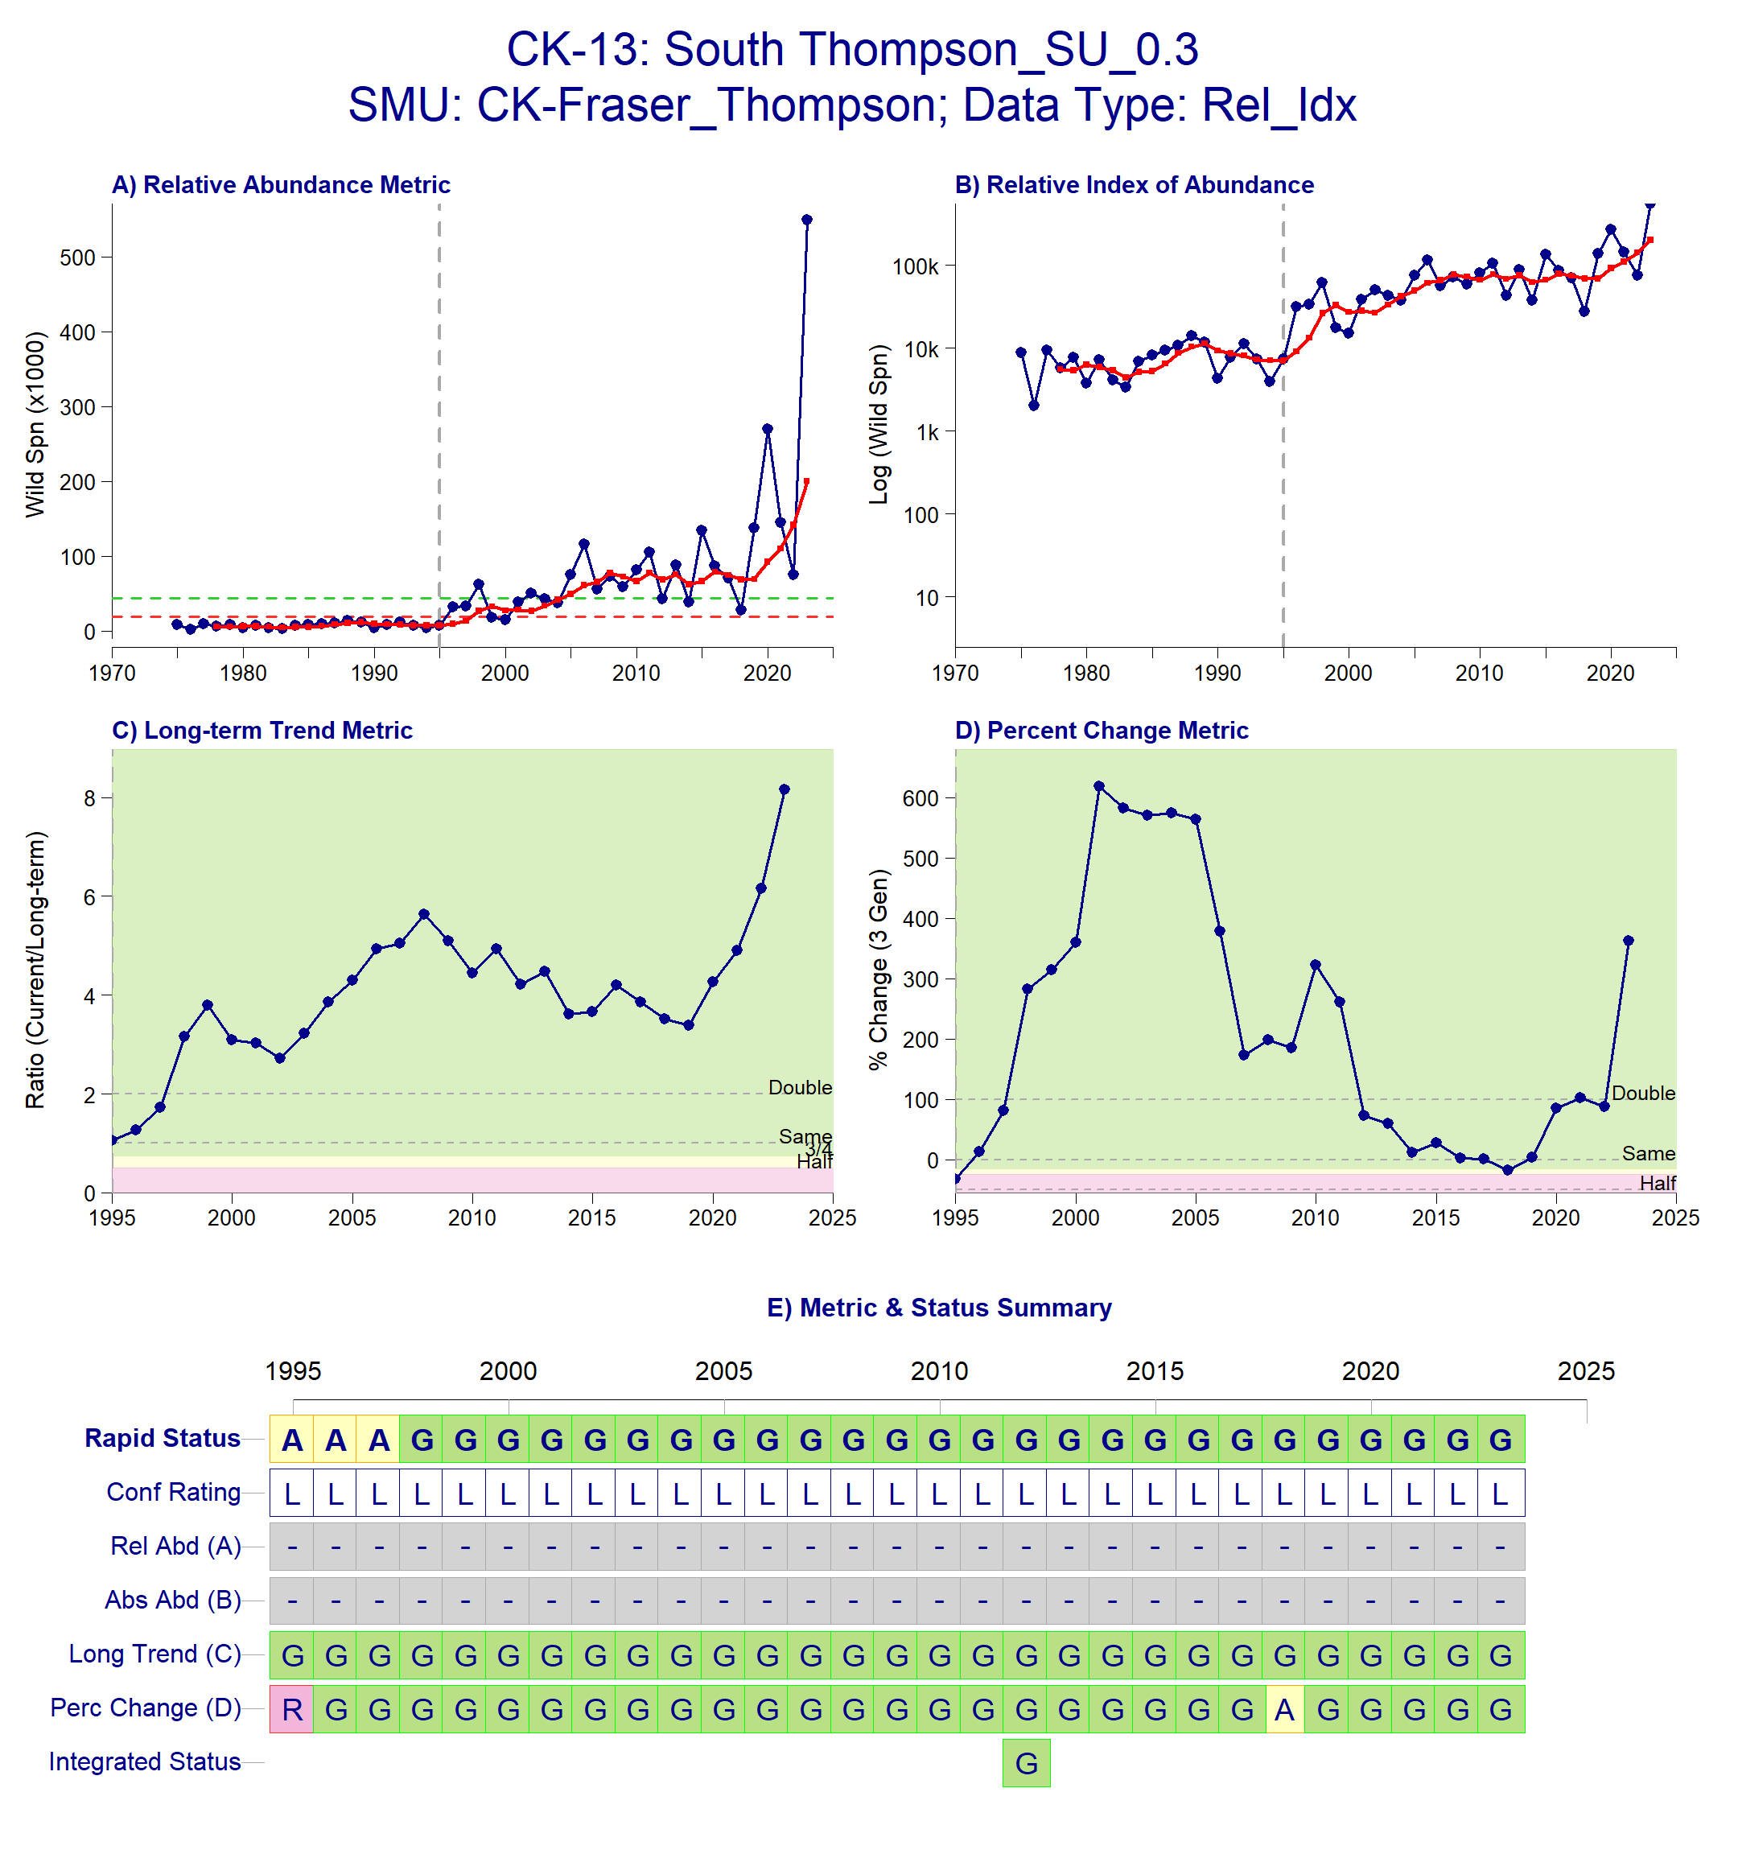
Figure 3: Metrics and Status for South Thompson SU 0.3 (CK-13). Panels on top show the four standard WSP metrics, calculated based on the available time series of spawner abundances. Bottom panel summarizes the status for each individual metric and shows the resulting WSP rapid status for the CU with a confidence rating. If integrated WSP status assessments have been completed for this CU, they are shown on the last row (IntStatus). Note that metric benchmarks may differ from algorithm thresholds, since thresholds approximate the status determination process from past WSP integrated status assessments (see Figure 4 and Table 5).
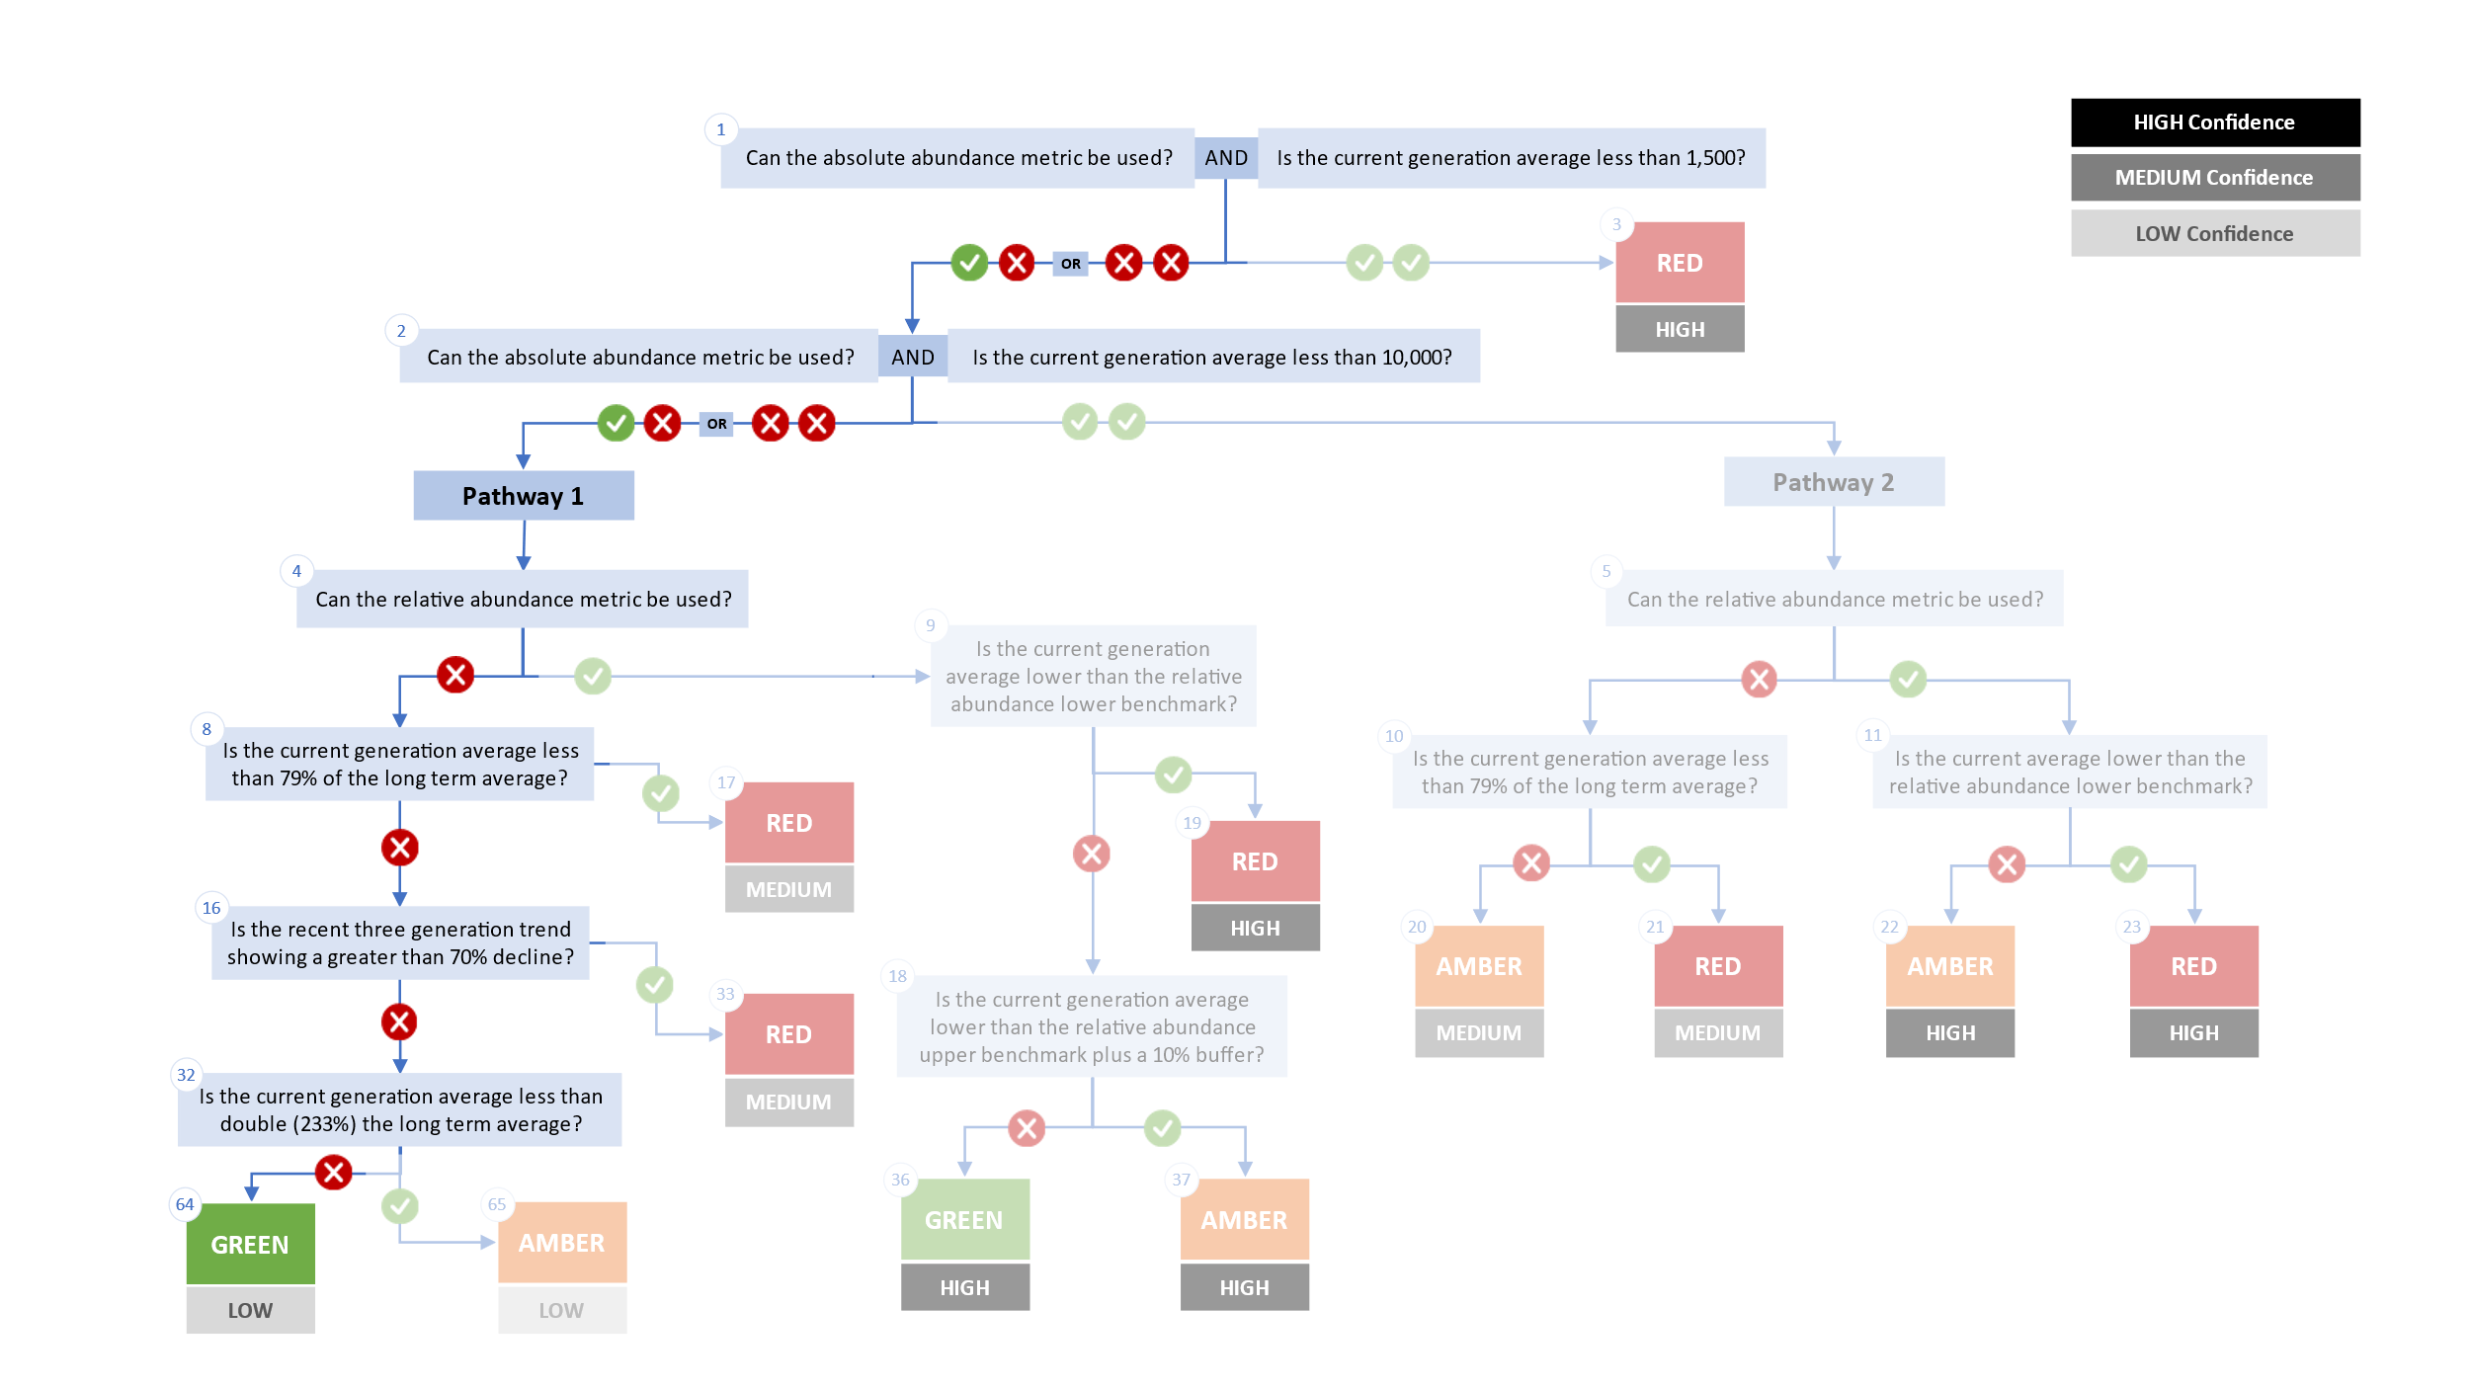
Figure 4. Algorithm pathway taken to assess status for the South Thompson SU 0.3 in 2023. The recent generational average is above 233% of the long term average (node 32). Status for this CU is therefore designated as Green with Low confidence at Node 64.
Table 5: Decision tree path given data and metric values for the South Thompson SU 0.3 in 2023; this aligns with Figure 4 above. For each node, the algorithm decision is made by comparing the CUs current metric value to the metric threshold and answering Yes or No, running through sequential nodes and decisions until the final WSP rapid status for that CU and year is reached.
Node | Metric | Metric Threshold | CUs Current Value | Decision
1 | Absolute Abundance | <1,500 | 200,125 | NO, NO
2 | Absolute Abundance | <10,000 | 200,125 | NO, NO
4 | Relative Abundance | Available? | No | NO
8 | Long term trend | <79% of long term average | 200,125 | NO
16 | Percent Change | >70% decline |  | NO
32 | Long term trend | < 233% of long term average |  | NO
64 | FINAL STATUS NODE |  |  | GREEN, LOW

CK-15 Shuswap River SU 0.3
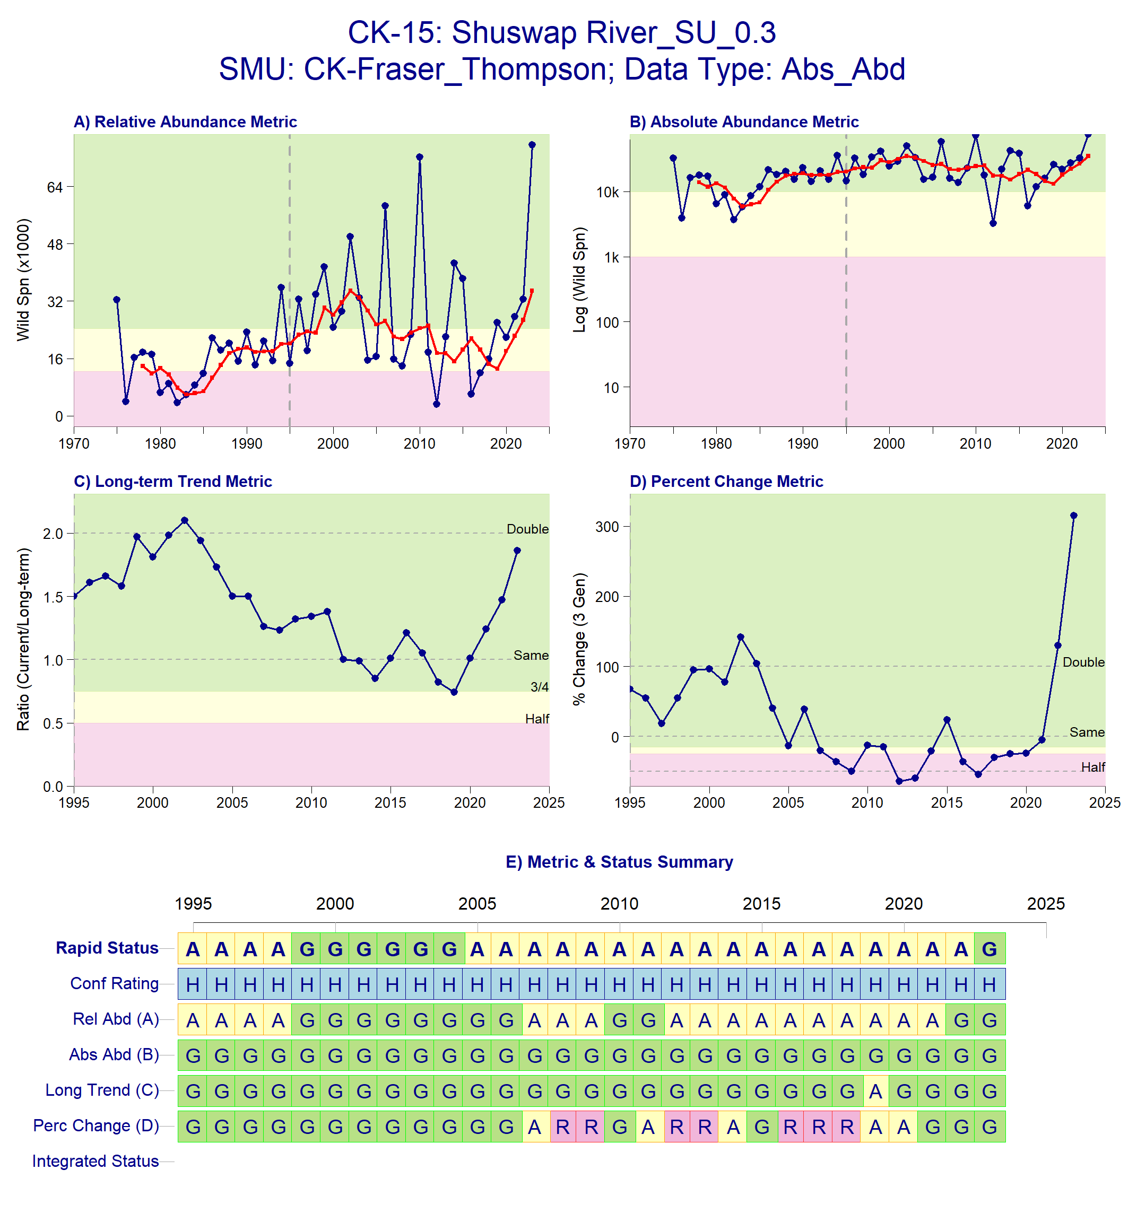
Figure 5: Metrics and Status for Shuswap River SU 0.3 (CK-15). Panels on top show the four standard WSP metrics, calculated based on the available time series of spawner abundances. Bottom panel summarizes the status for each individual metric and shows the resulting WSP rapid status for the CU with a confidence rating. If integrated WSP status assessments have been completed for this CU, they are shown on the last row (IntStatus). Note that metric benchmarks may differ from algorithm thresholds, since thresholds approximate the status determination process from past WSP integrated status assessments (see Figure 6 and Table 6).
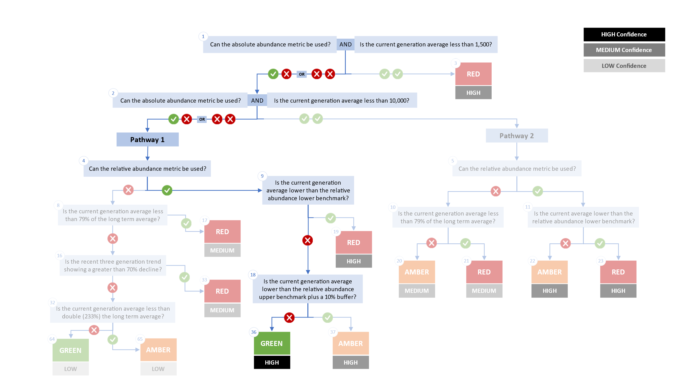
Figure 6. Algorithm pathway taken to assess status for the Shuswap River SU 0.3 in 2023. The recent generational average falls above the relative abundance lower benchmark threshold (node 18). Status for this CU is therefore designated as Green with High confidence at Node 36.
Table 6: Decision tree path given data and metric values for the Shuswap River SU 0.3 in 2023; this aligns with Figure 6 above. For each node, the algorithm decision is made by comparing the CUs current metric value to the metric threshold and answering Yes or No, running through sequential nodes and decisions until the final WSP rapid status for that CU and year is reached.
Node | Metric | Metric Threshold | CUs Current Value | Decision
1 | Absolute Abundance | <1,500 | 34,879 | YES, NO
2 | Absolute Abundance | <10,000 | 34,879 | YES, NO
4 | Relative Abundance | Available? |  | YES
9 | Relative Abundance | < 12,410 | 34,879 | NO
18 | Relative Abundance | < 26,833 | 34,879 | NO
36 | FINAL STATUS NODE |  |  | GREEN, HIGH

Cited and other Key References
DFO. 2016. Integrated biological status of Southern British Columbia Chinook salmon (Oncorhynchus tshawytscha) under the Wild Salmon Policy.
DFO. 2022. Methodologies and guidelines for defining limit reference points for Pacific Salmon. CSAS SAR 2022/030. pp. 16.
DFO. 2023. Science advice on guidance for limit reference points under the fish stocks provisions. Canadian Science Advisory Secretariat Science Advisory Report 2023/009(February).
Dionne, K., Parken, C., Weir, L., Doutaz, D., Bailey, R., Jenewein, B., Miller-saunders, K., Labelle, M., Welch, P., Trouton, N., Mozin, P., and Walsh, M. 2023. Recovery Potential Assessment for Southern British Columbian Chinook Populations , Fraser and Southern Mainland Chinook.
Holt, Carrie.A., Holt, K., Wor, C., Warkentin, L., Connors, B., Grant, S.C.H., and Huang, A.-M. 2023a. Guidelines for Defining Limit Reference Points for Pacific Salmon Stock Management Units. Can. Sci. Adv. Sec. Res. Doc. 2023/009: iv + 66.
Holt, K., Holt, C.A., Warkentin, L., Wor, C., Davis, B., Arbeider, M., Bokvist, J., Crowley, S., Grant, S.C.H., Luedke, W., McHugh, D., Picco, C., and Will, P. Van. 2023b. Case Study Applications of LRP Estimation Methods to Pacific Salmon Stock Management Units. Can. Sci. Advis. Sec. Res. Doc. 2023/010: iv + 129.
Parken, C.K., McNichol, R.E., and Irvine, J.R. 2006. Habitat-based methods to estimate escapement goals for data limited Chinook salmon stocks in British Columbia, 2004. Canadian Science Advisory Secretariat (083): vii+1-67.
Pestal, G., Macdonald, B.L., Grant, S.C.H., and Holt, C.A. 2023. State of The Salmon: Rapid status assessment approach for Pacific salmon under Canada’s Wild Salmon Policy. Can. Tech. Rep. Fish. Aquat. Sci. (3570): 1–200.

Appendix A: WSP rapid status approach details

The decision tree sequence is as follows (see Figure A1; Table A1, A2):
- The first question is whether or not a CU has a current absolute abundance value, and if so, whether or not this value falls below the lower threshold of 1,500 (which adds a buffer to Committee on the Status of Endangered Wildlife in Canada (COSEWIC) Criterion D1 for small population size of 1,000). If the answer to this question is Yes, then the CU is assigned Red (node 3), with High confidence.
- If the answer to the first question is No, then the second question is whether or not the CU has a current absolute abundance value, and if so, whether or not the current abundance is below the upper threshold of 10,000, which is COSEWIC's Criterion C upper benchmark. This second question splits the decision nodes into two Pathways: Pathway 1 (No to this question) and Pathway 2 (Yes to this question).
  - Pathway 1: is where a CU either does not have a current absolute abundance value, or has these data, and it falls above the upper threshold for this metric. This pathway is split with the question: can this CU be assessed with a relative abundance metric. If the answer is Yes, a Red (nodes 19), Amber (nodes 37) or Green (node 36) WSP rapid status is assigned, with High confidence, depending on where the current abundance value falls relative to this metric’s lower and upper thresholds. If the answer is NO, then comparisons are made between the CUs current abundances and percent change to thresholds for these metrics, which assign a Red with Medium confidence, or Green or Amber with Low confidence status.
  - Pathway 2: is where a CU has absolute abundance data, and these abundances fall between the lower and upper thresholds. In this pathway, absolute abundances restrict WSP rapid statuses to only Amber or Red. This pathway is split with the question: can this CU be assessed with a relative abundance metric. If the answer is Yes, an Amber (node 22) with Medium confidence, or Red (node 23) with High confidence, is assigned, depending on whether the CUs current abundance value falls above the relative abundance metric lower threshold or below. If the CU cannot be assessed with a relative abundance metric, then it is compared to the lower threshold of the Long-Term trend metric and assigned Amber (node 20) with Medium confidence if above, or Red (node 21) with Medium confidence if below.

Table A1. Biological status zones under the Wild Salmon Policy (WSP).

Status |  | Definition
 | Red | Poor status CU facing an imminent threat of extinction [revised definition, given alignment with COSEWIC Endangered statuses]
 | Amber | “While a CU in the Amber zone should be at low risk of loss, there will be a degree of lost production. Still, this situation may results when CUs share risk factors with other, more productive units”. Aligns with COSEWIC Threatened and Special Concern statuses.
 | Green | “identif[ies] whether harvest are greater than the level expected to provide on an average annual basis, the maximum annual catch for a CU, given existing conditions…there would not be a high probability of losing the CU”. Aligns with COSEWIC Not at Risk statuses.
 | DD | Data deficient. CUs have been designated as DD if there is no data available, or if the available data is insufficient for calculating status metrics (after quality control).

Table A2. WSP rapid status Learning Tree 3 status assignments by node (see Figure 1). This table presents the decisions in Learning Tree 3 that led to Red or Amber or Green status assignments; status outcomes depend on the pathway and decisions made. The final node that corresponds to the status assignment is presented below (see Figure 1).
Node | Status | Rule
Node3 | Red | Data Type is Absolute Abundance AND Absolute Abundance < 1,500
Node17 | Red | Data Type is Relative Index OR Absolute Abundance ≥ 1,500;  then Data Type is Relative Index OR Absolute Abundance ≥ 10,000;  then no Relative Abundance lower benchmark; then Long Term Trend < 79%
Node19 | Red | Data Type is Relative Index OR Absolute Abundance ≥ 1,500;  then Data Type is Relative Index OR Absolute Abundance ≥ 10,000  then have Relative Abundance lower benchmark;  then Relative Abundance < Relative Abundance lower benchmark
Node20 | Amber | Data Type is Relative Index OR Absolute Abundance ≥ 1,500;  then Data Type is Absolute Abundance AND Absolute Abundance<10,000;  then no Relative Abundance lower benchmark; then Long Term Trend ≥ 79%
Node21 | Red | Data Type is Relative Index OR Absolute Abundance ≥ 1,500;  then Data Type is Absolute Abundance AND Absolute Abundance<10,000;  then no Relative Abundance lower benchmark; then Long Term Trend < 79%
Node22 | Amber | Data Type is Relative Index OR Absolute Abundance ≥ 1,500;  then Data Type is Absolute Abundance AND Absolute Abundance<10,000;  then have Relative Abundance lower benchmark;  then Relative Abundance ≥ Relative Abundance lower benchmark
Node23 | Red | Data Type is Relative Index OR Absolute Abundance ≥ 1,500;  then Data Type is Absolute Abundance AND Absolute Abundance<10,000;  then have Relative Abundance lower benchmark;  then Relative Abundance < Relative Abundance lower benchmark
Node33 | Red | Data Type is Relative Index OR Absolute Abundance ≥ 1,500;  then Data Type is Relative Index OR Absolute Abundance ≥ 10,000;  then no Relative Abundance lower benchmark;  then Long Term Trend ≥ 79%; then Percent Change < -70
Node36 | Green | Data Type is Relative Index OR Absolute Abundance ≥ 1,500;  then Data Type is Relative Index OR Absolute Abundance ≥ 10,000  then have Relative Abundance lower benchmark;  then Relative Abundance ≥ Relative Abundance lower benchmark;  then Relative Abundance ≥ Relative Abundance upper benchmark x 1.1
Node37 | Amber | Data Type is Relative Index OR Absolute Abundance ≥ 1,500;  then Data Type is Relative Index OR Absolute Abundance ≥ 10,000  then have Relative Abundance lower benchmark;  then Relative Abundance ≥ Relative Abundance lower benchmark;  then Relative Abundance < Relative Abundance upper benchmark x 1.1
Node64 | Green | Data Type is Relative Index OR Absolute Abundance ≥ 1,500;  then Data Type is Relative Index OR Absolute Abundance ≥ 10,000;  then no Relative Abundance lower benchmark;  then Long Term Trend ≥ 79%; then Percent Change < -70  then Long Term Trend ≥ 233
Node65 | Amber | Data Type is Relative Index OR Absolute Abundance ≥ 1,500;  then Data Type is Relative Index OR Absolute Abundance ≥ 10,000;  then no Relative Abundance lower benchmark;  then Long Term Trend ≥ 79%;  then Percent Change < -70  then Long Term Trend < 233

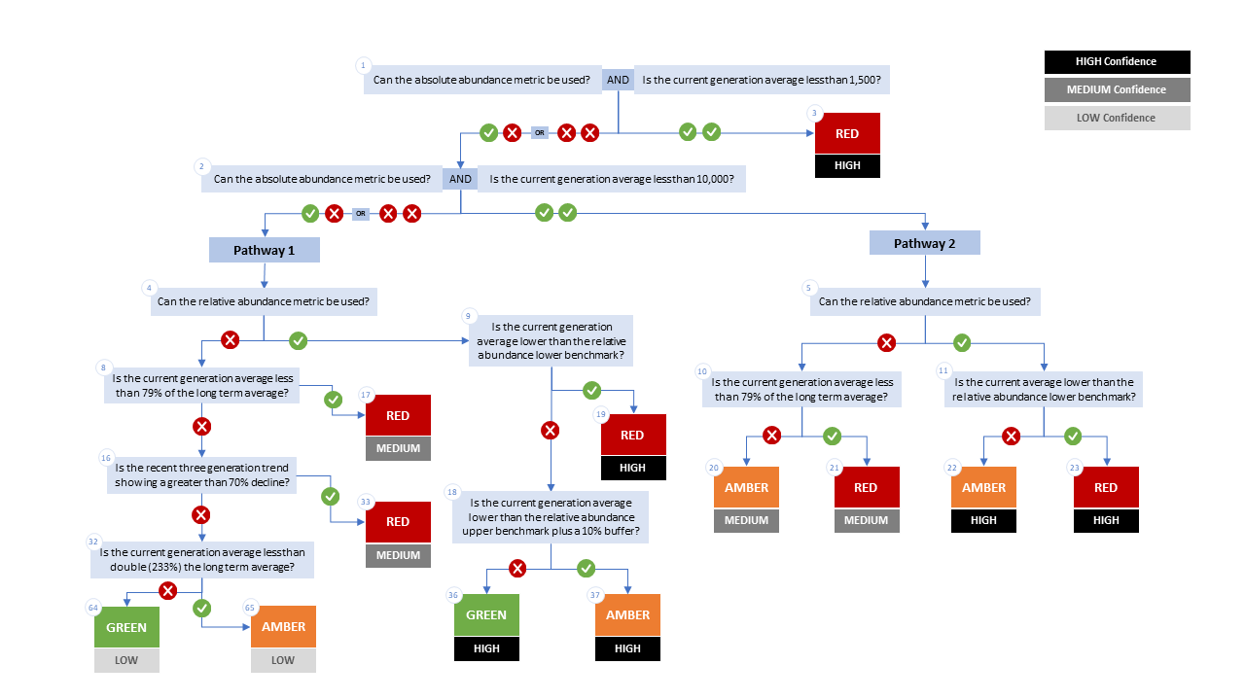

Figure A1. WSP rapid status decision tree (Table 2 includes written descriptions). To assess a CU, metric values are compared to thresholds presented at each decision point. Yes or No answers split each path of the decision tree, terminating at WSP rapid status assignments. The different splits are identified as nodes: 1 to 65. Pathway 1 is taken when the CU has no absolute abundance data, or these data exist, but fall above its upper threshold of 10,000. Pathway 2 is taken when the CU has absolute abundance data and these fall under its upper benchmark of 10,000.

Appendix B: Meeting History and Participants
Tables and summaries of meetings and participants, specifically participants who identified as a subject matter expert for one or more CUs.
Table B1. Participants for the expert review of Fraser Interior Area Chinook held January 31, 2025 1:00-4:30pm PST
Attendee | Affiliation
Chuck Parken | DFO
Colin Bailey | DFO
Morgan Dunne | DFO
Nicole Trouton | DFO
Amber Messmer | DFO
Sue Grant | DFO
Bronwyn MacDonald | DFO
Simon-Luc Noel | DFO
Isabella Borea | DFO
Marissa Glavas | DFO
Elinor McGrath | Okanagan Nation Alliance
Peter Nicklin | Tŝilhqot’in National Government
Kelsey Campbell | A’Tlegay Fisheries
Michelle Walsh | Shuswap Nation

Consensus: general agreement of group as a whole, or absence of evidence-based opposition to conclusions. Determined by the “weight of evidence” (scientific data, information, and analysis ) where multiple results are reported. In the event of disagreements, equally plausible conclusions can be reported. Dissenting views must be clearly described in the narrative.

